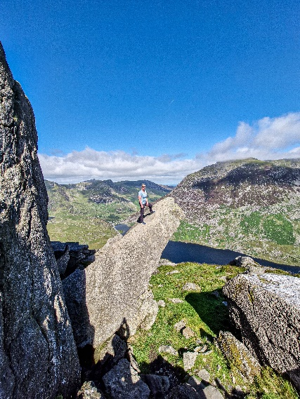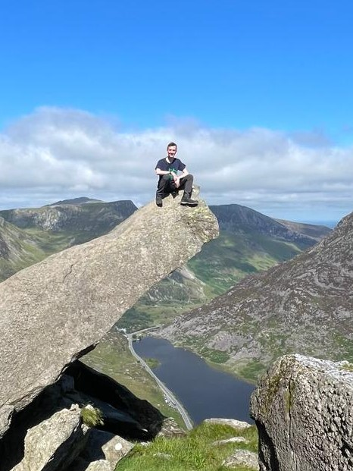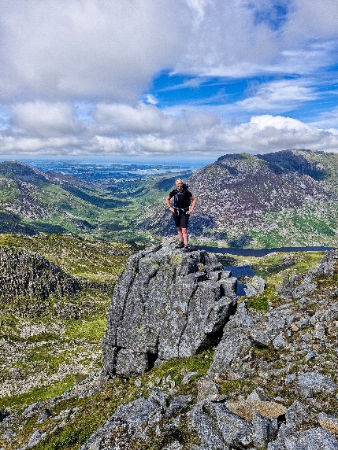
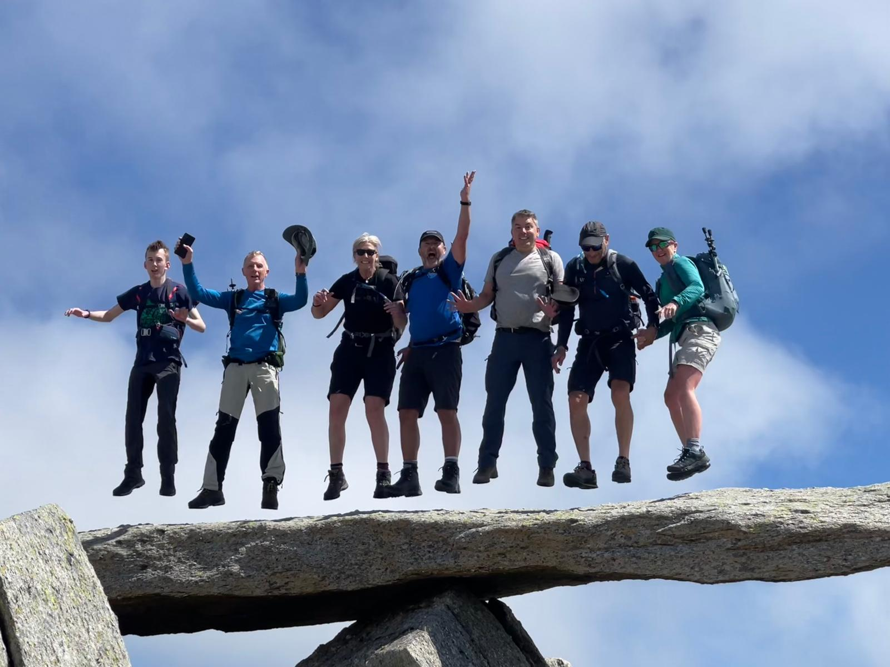
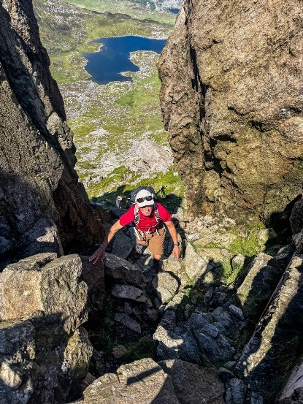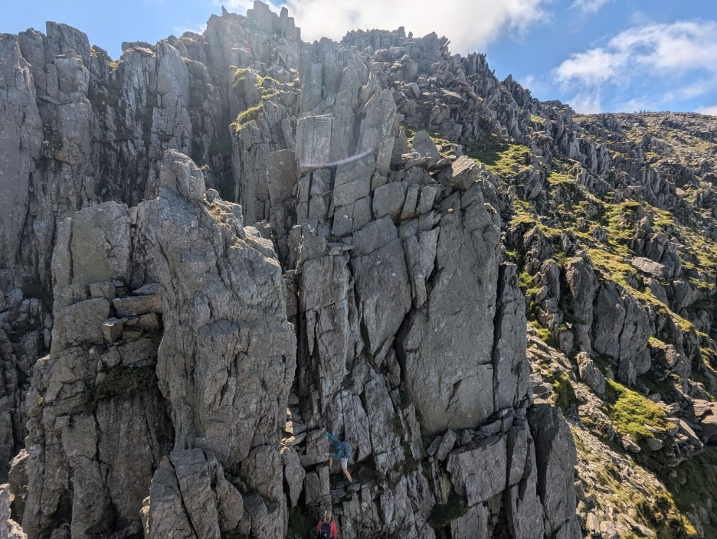
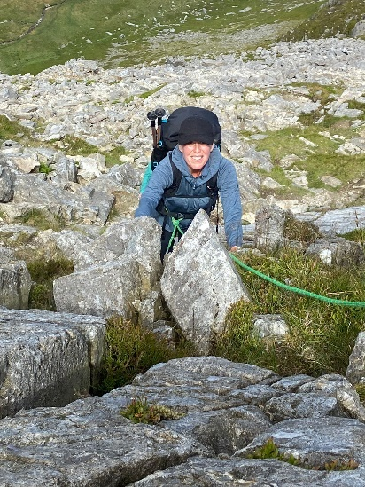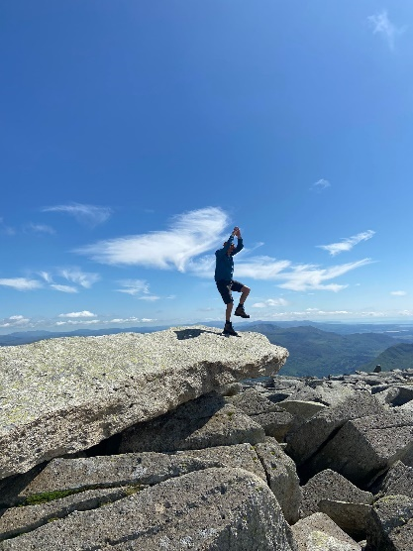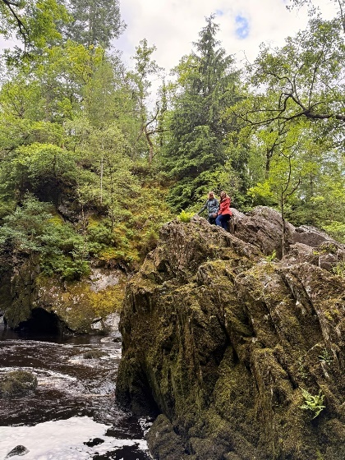
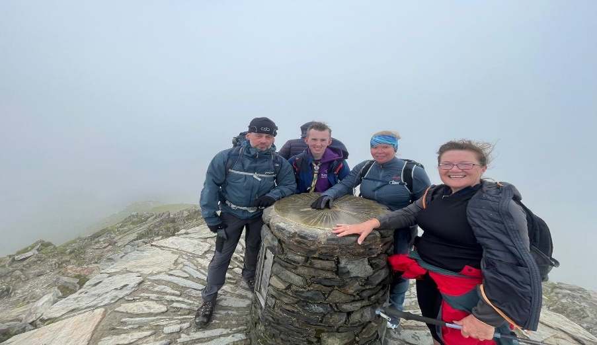
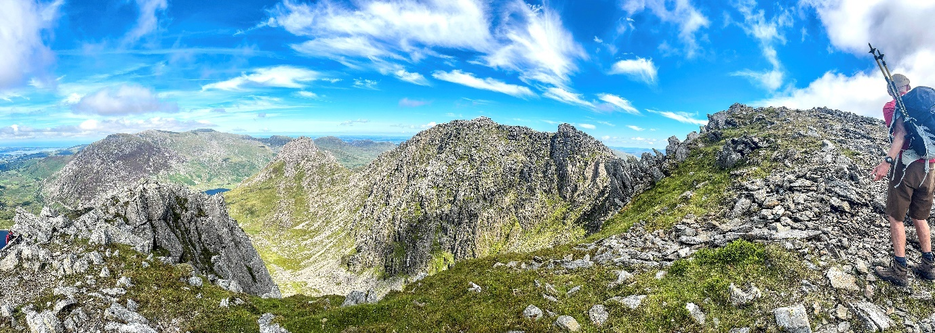

‘Some of the CHAOS club well and truly earned their cake this week after spending an epic few days away staying in the 5* Rocks Hostel in Snowdonia National Park, Wales benefiting from plenty of fresh air and exercise.
The club split into smaller groups and enjoyed walks and climbing of varying difficulties and experiences enjoying the stunning scenery. These included, climbing Mount Snowdon, Tryfan then on to Glyder Fach, a 12 mile hike taking in Cwm Glas Crafnant Nature Reserve and a trip to Fairy Glen!
Take a look at some of the photos which have captured the fun times had by all and the spectacular scenery!
The club has lots of activities arranged for the year and a further 2 for July which include...A wild overnight camp in the Cheviot Hills on 18th July and a navigation skills day on 20th July in Simonside Hills....August so far includes a overnight stay at Ambleside YHA on Sunday 3rd August - A sports and social van will be utilised to drive the group to the lake district and a hike to and from the YHA will be planned (Total cost of £35 What a bargain!!)
To find out more about the trips and day hikes or to book a place just drop the club an email to chaosclub2018@gmail.com You just need to be a member of the sports and Social club
There is also a Private Facebook and Instagram pages (Chaos_clubnp) which has captured many of the previous adventures!’

